STUDENT NAME: KHUMALO THOBANI

STUDENT NUMBER: ST10092282

MODULE: PROGRAMMING 2A

PART: PART 2

TYPE: ASSIGNMENT

a brief description (100 to 200 words) of what you changed based on your lecturer’s feedback.

(Words count: 224)

Based on the feedback provided by the lecturer Mr Gololo for my Part 2 of the project, several changes were made in my Part 3 to address the areas of improvement. (Geeks for Geeks, 2021)

The was not much to fix since I got 97 on my part two but I did made some improvements where I did get full marks. (Tutorials Points, 2020)

recipe scaling functionality was enhanced based on the feedback received. All required factors could now scale the recipe, and units of measurement were changed accurately when scaling. The display adapted well to changing values, ensuring a smooth scaling experience. (Tutorials Points, 2020)

Other areas of improvement, such as resetting the recipe scale and clearing data to enter a new recipe, were addressed. The program now allows for resetting the recipe to its original values, and confirmation is required before clearing data. New data entry is handled effectively. (Tutorials Points, 2020)

Overall, the changes made in Part 3 aimed to meet the required standards highlighted in the part 2 feedback, including repository management, app functionality, application structure, coding standards, and documentation. (Tutorials Points, 2020)

GITHUB REPO LINK

<https://github.com/IIEWFL/prog6221-part-2-ST10092282.git>

SCREENSHOOTS

COMMITS

COMMITS HISTORY

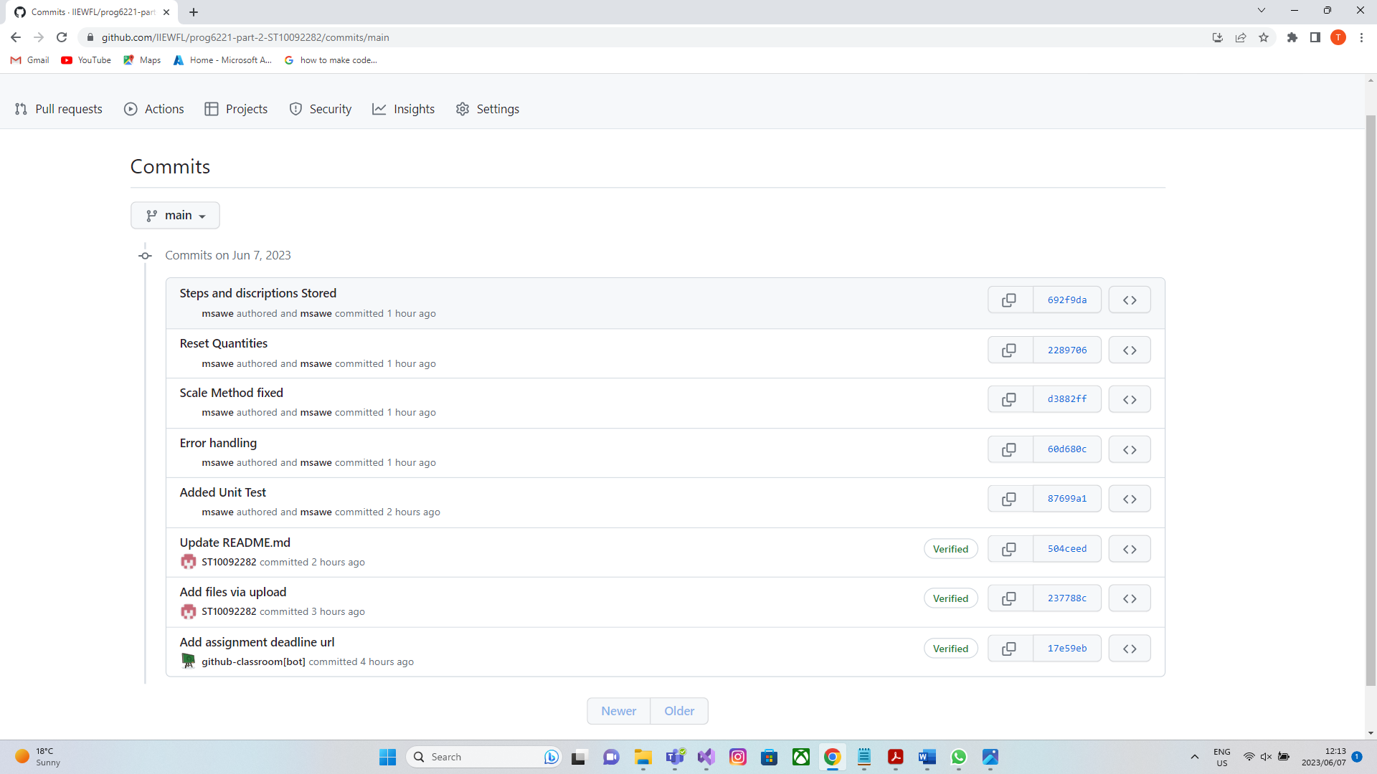

PART 2 TAG

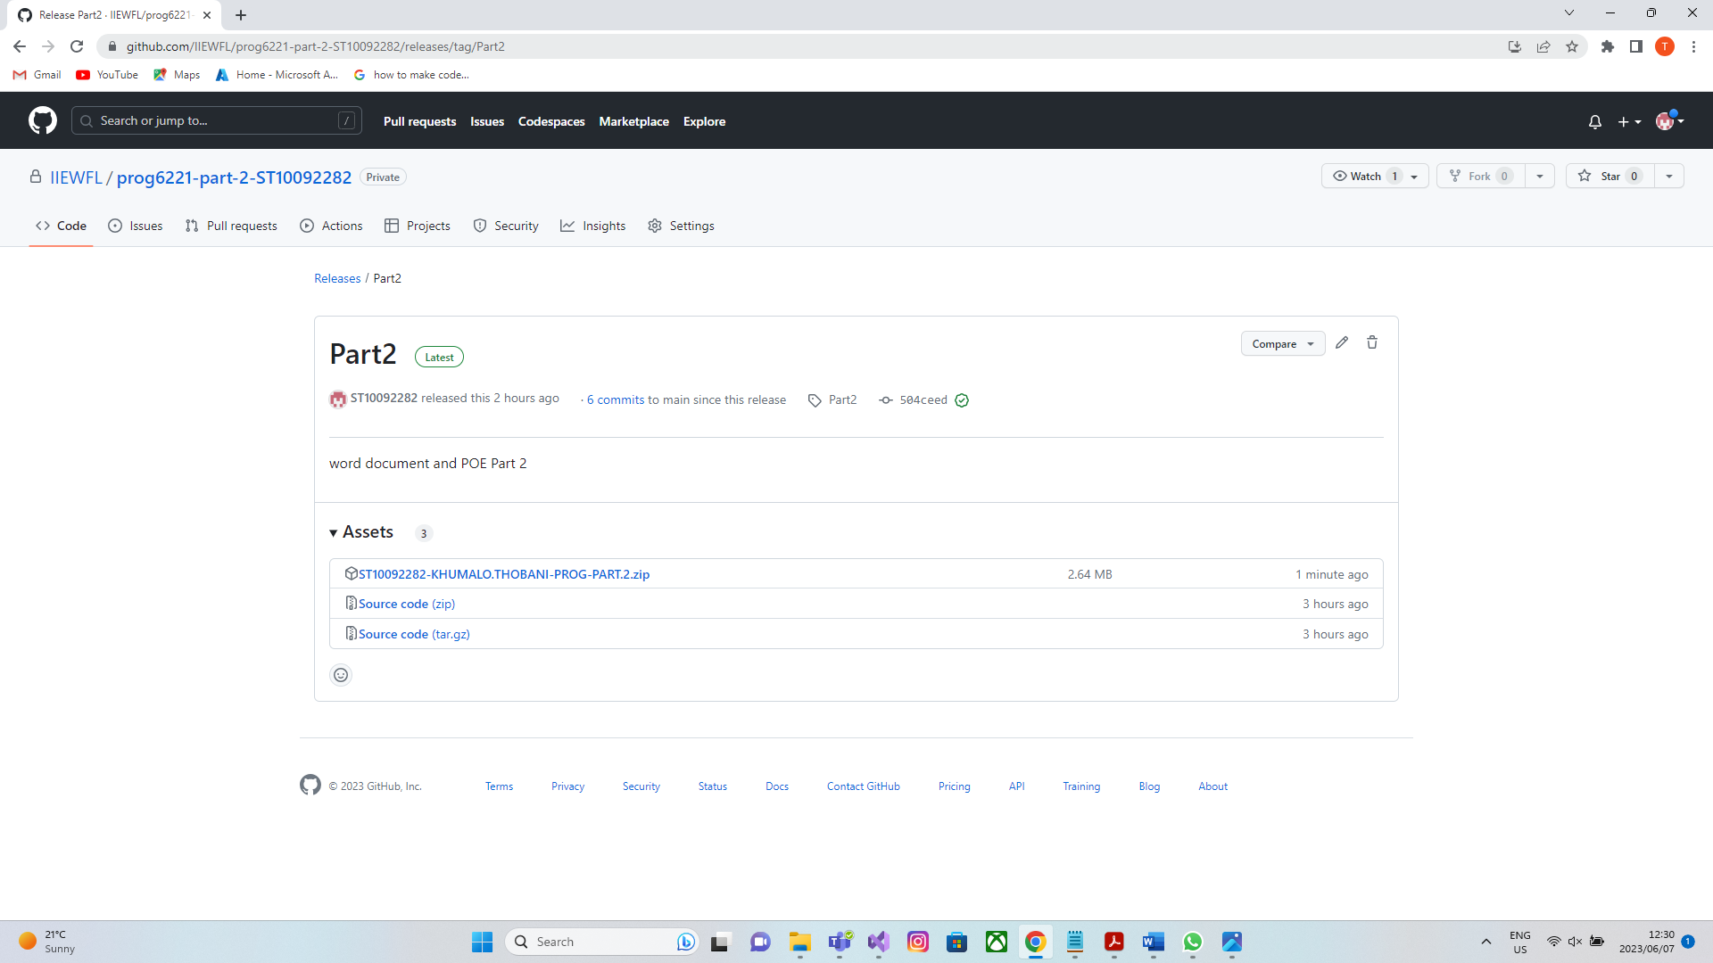

REFERENCES

W3 school. 2022.C# for loop, 21 December 2022. [Online]. Available at: <https://www.w3schools.com/cs/cs_for_loop.php>

[Accessed 25 March 2023]

Tutorials Teacher. 2020.C# for Loops, 17 June 2020. [Online]. Available at:

<https://www.tutorialsteacher.com/csharp/csharp-for-loop>

[Accessed 22 March 2023]

Geek for Geeks. 2021.Switch statements in c#, 05 April 2021. [Online]. Available at:

<https://www.geeksforgeeks.org/switch-statement-in-c-sharp/>

[Accessed 07 April 2023]